**NAAN MUDALVAN ASSIGNMENT**

**NAME: SARATHI D**

**DEPARTMENT**: B.E - Electronic and Communication Engineering

**COLLEGE**: 4225 - University college of engineering, Villupuram

**NAANMUDHALVAN COURSE**: DIGITAL MARKETING

**NM ID**: 16CAA1D51E3DEA599A043385CCE37DE7

ASSIGNMENT 1:

Create a blog or website using Blogspot and word press. Customize the theme design and post new article with 500 words.

Link : <https://chandrabalan.wordpress.com/2023/10/27/the-power-and-versatility-of-wordpress-your-ultimate-website-solution/>

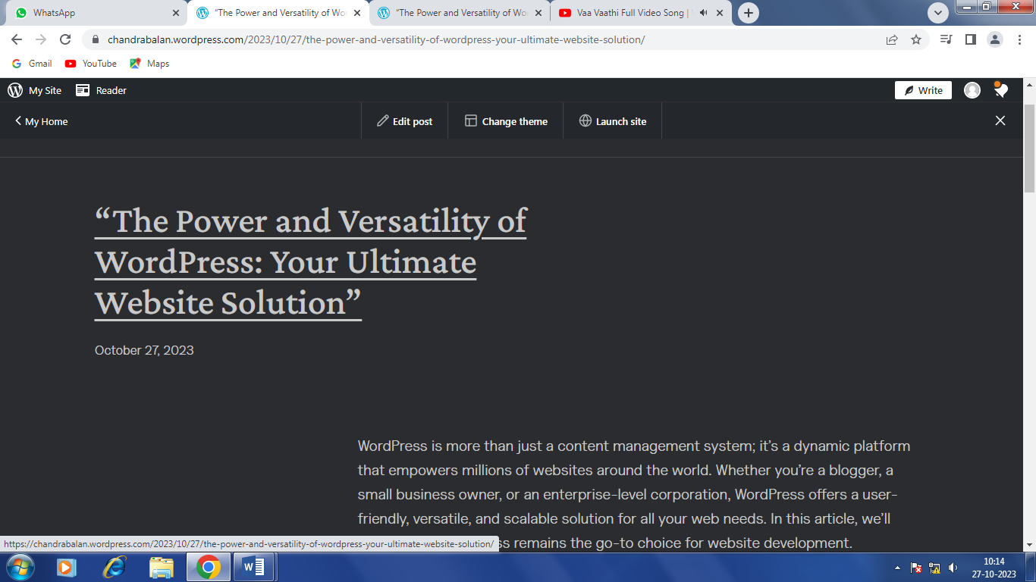

ASSIGNMENT 2:

Create a new Facebook business page and post one social media poster for your brand.

Link : <https://www.facebook.com/profile.php?id=61552157976745>

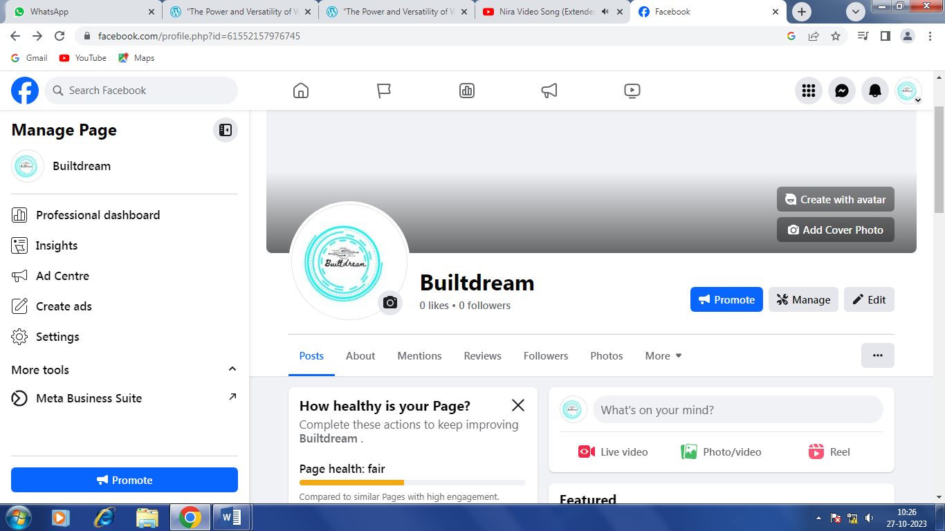

ASSIGNMENT 3:

Create and design a advertisement poster using Canva.

Link : <https://www.canva.com/design/DAFxfsXzX1o/DJJrng_cwHc86WTYlHtscw/edit?utm_content=DAFxfsXzX1o&utm_campaign=designshare&utm_medium=link2&utm_source=sharebutton>

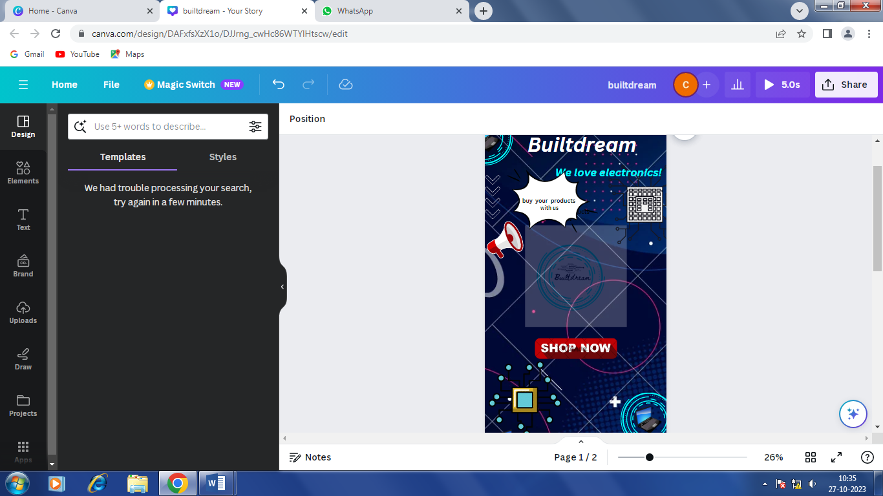

ASSIGNMENT 4:

Create an E mail newsletter design using Mailchimp or Canva tool.

Link : <https://www.canva.com/design/DAFyXqzPAPs/EKOOvOmEU3p8XeiYR9eUXg/edit?utm_content=DAFyXqzPAPs&utm_campaign=designshare&utm_medium=link2&utm_source=sharebutton>

